OO Programming Fundamentals

Practical Class 3 – Week 7th October 2013

- Create a new folder in your java folder on your G drive and call it practical03
- Save all the following exercises into the practical03 folder
- Ensure that you move to the correct folder when using the Command Prompt Window:
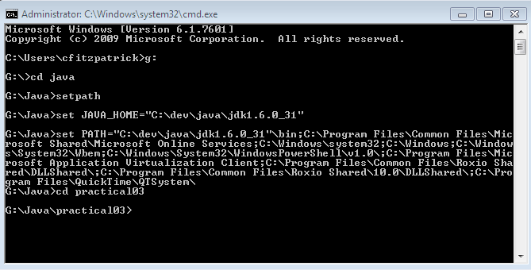
- You must run setpath from whichever folder it is stored in.

Exercise 1
Enter Program from book (Pg 41) - If statement to determine what to wear depending on the weather being good.
Save as ex3a.java

Sample Output:

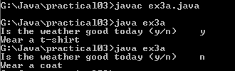

Exercise 2
Enter Program from notes (Lecture 8th October 2013: Selection – available on Moodle) - If statement to calculate your rate of tax depending on your yearly salary.
Save as ex3b.java

Sample Output
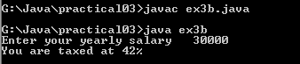
Or


Exercise 3
Write a program which asks a waiter the cost of a customer’s meal. If the cost of the meal is €10 or more, calculate a 5% discount on the bill and print the new value of the bill to the screen, otherwise give a message saying no discount.
Save as ex3c.java
Sample Output:
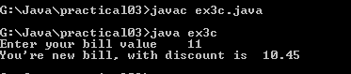
or


Exercise 4
A senior salesperson is paid £400 a week and a junior salesperson £290 a week. Write a program that accepts as input a salesperson's status in the integer variable status. If status equals 1 the senior salespersons salary should be displayed. Otherwise the junior salespersons salary should be displayed.
Save as ex3d.java
Sample Output
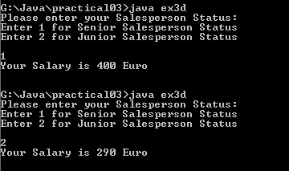

Exercise 5
Write a program to read any 2 integer values and store them in variables x and y. Write the code to determine which value is greater than the other and print one of the messages: x is the larger value or y is the larger value.
Save as ex2e.java

Sample Output:
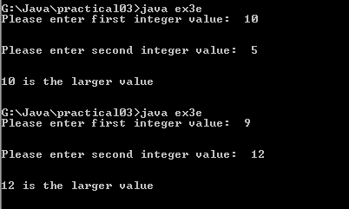

Exercise 6
Write a program to read an integer value from the keyboard and print one of the following messages: “Multiple of three” or “Not multiple of three”.
Use the Modulus Operator:
If the value entered by the user, when divided by 3, has no remainder then the value is a multiple of 3.
else
If the value entered by the user, when divided by 3, has a remainder then the value is not a multiple of 3.
(integer value entered % 3 == 0)

Save as ex3f.java
Sample Output:
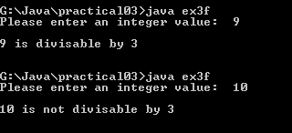

Completing this weeks’ Practical:
- When you submit work, you will send it in zip file format.
- To create a zip file of your practical work:
  - In Windows Explorer, right click on the practical03 folder that contains your work.
  - When the context menu appears, choose the Send to option, followed by the Compressed (zipped) folder.

  - This will create a new file called practical03.zip in your current folder, as highlighted in the image below.
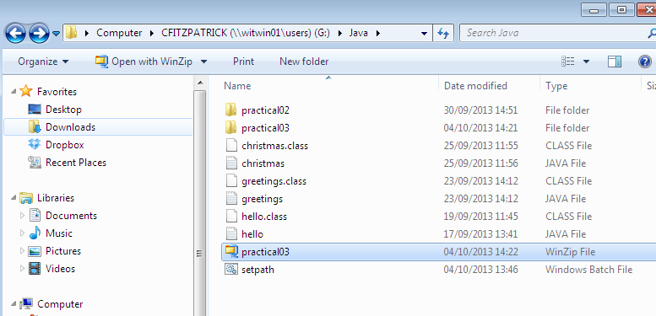

- Note: If you are using your own laptop, you can choose to install very good (and free) compression software called 7zip. Just search for it in Google and download it.

*** It is this zipped file that you will upload into Moodle.***

